# CS 255 System Design Document - Tristin Raymond

## UML Diagrams

### UML Use Case Diagram

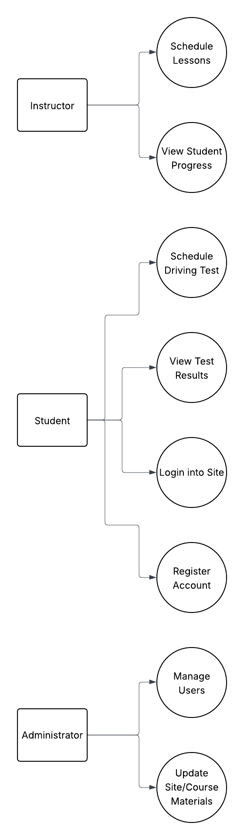

### UML Activity Diagrams

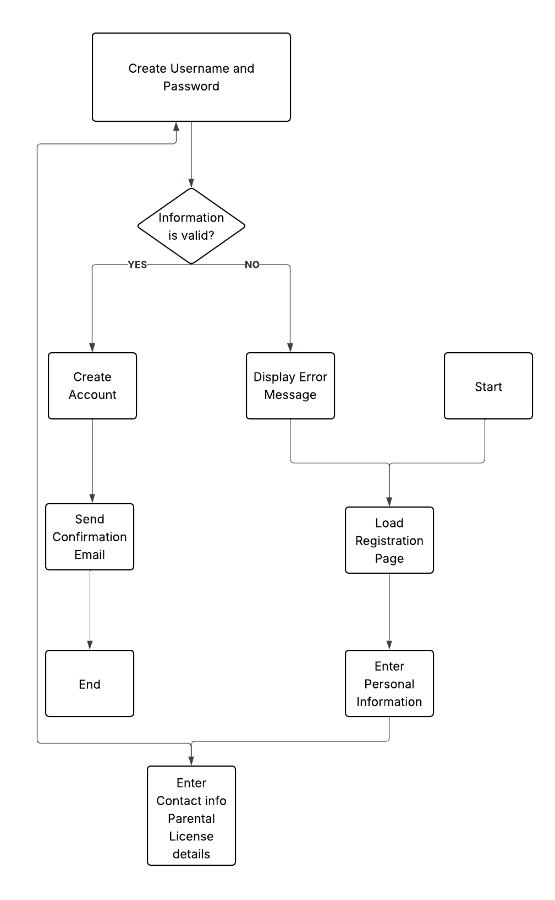

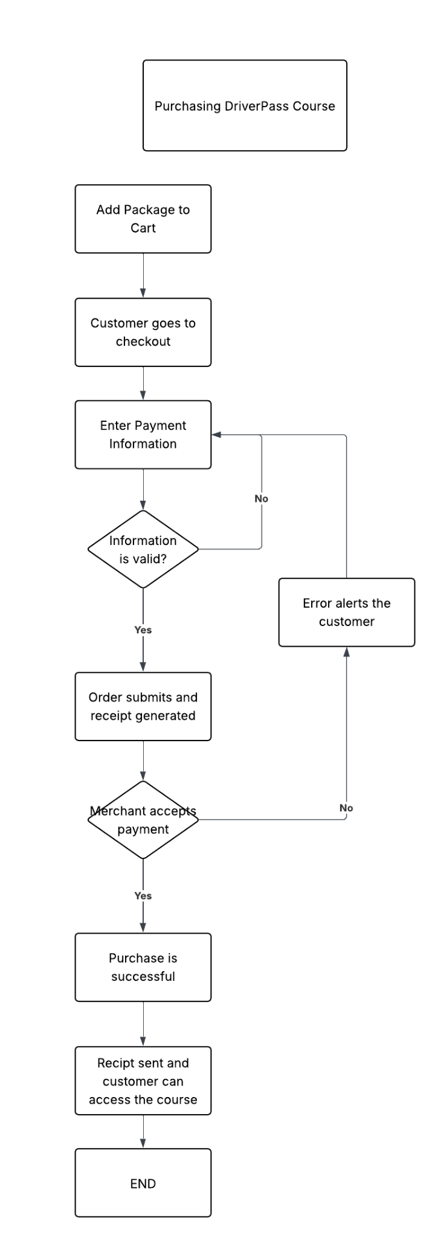

### UML Sequence Diagram

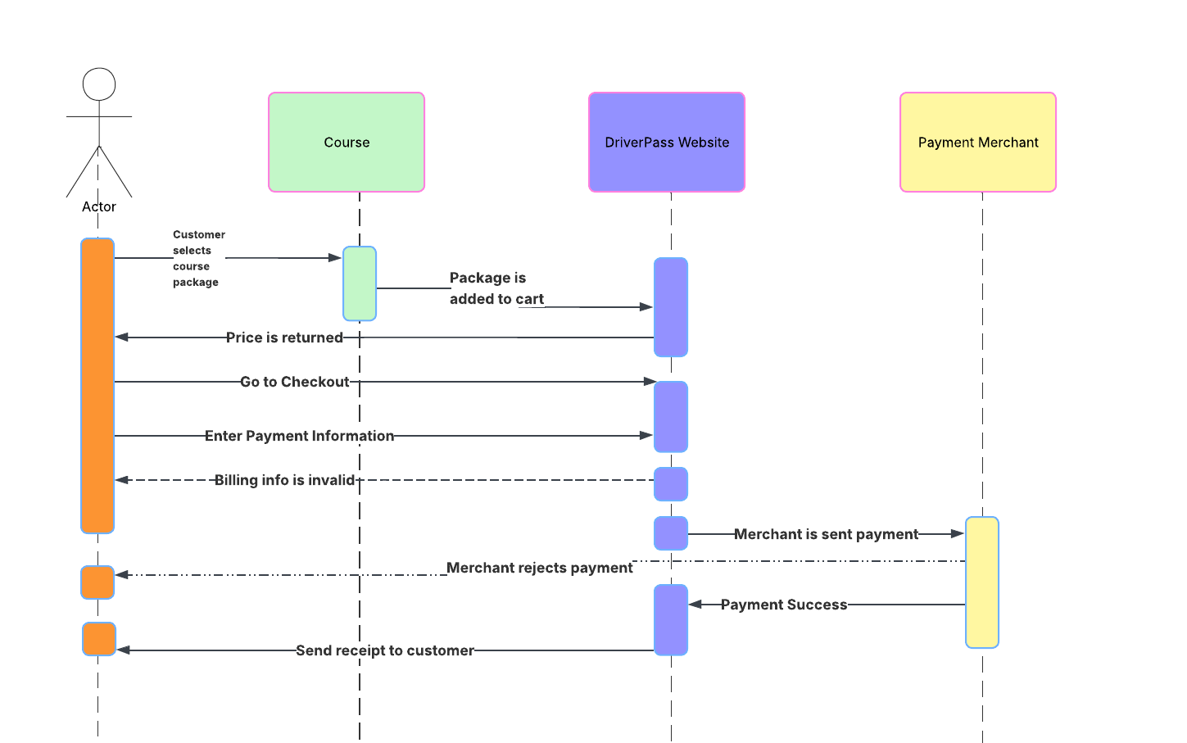

### UML Class Diagram

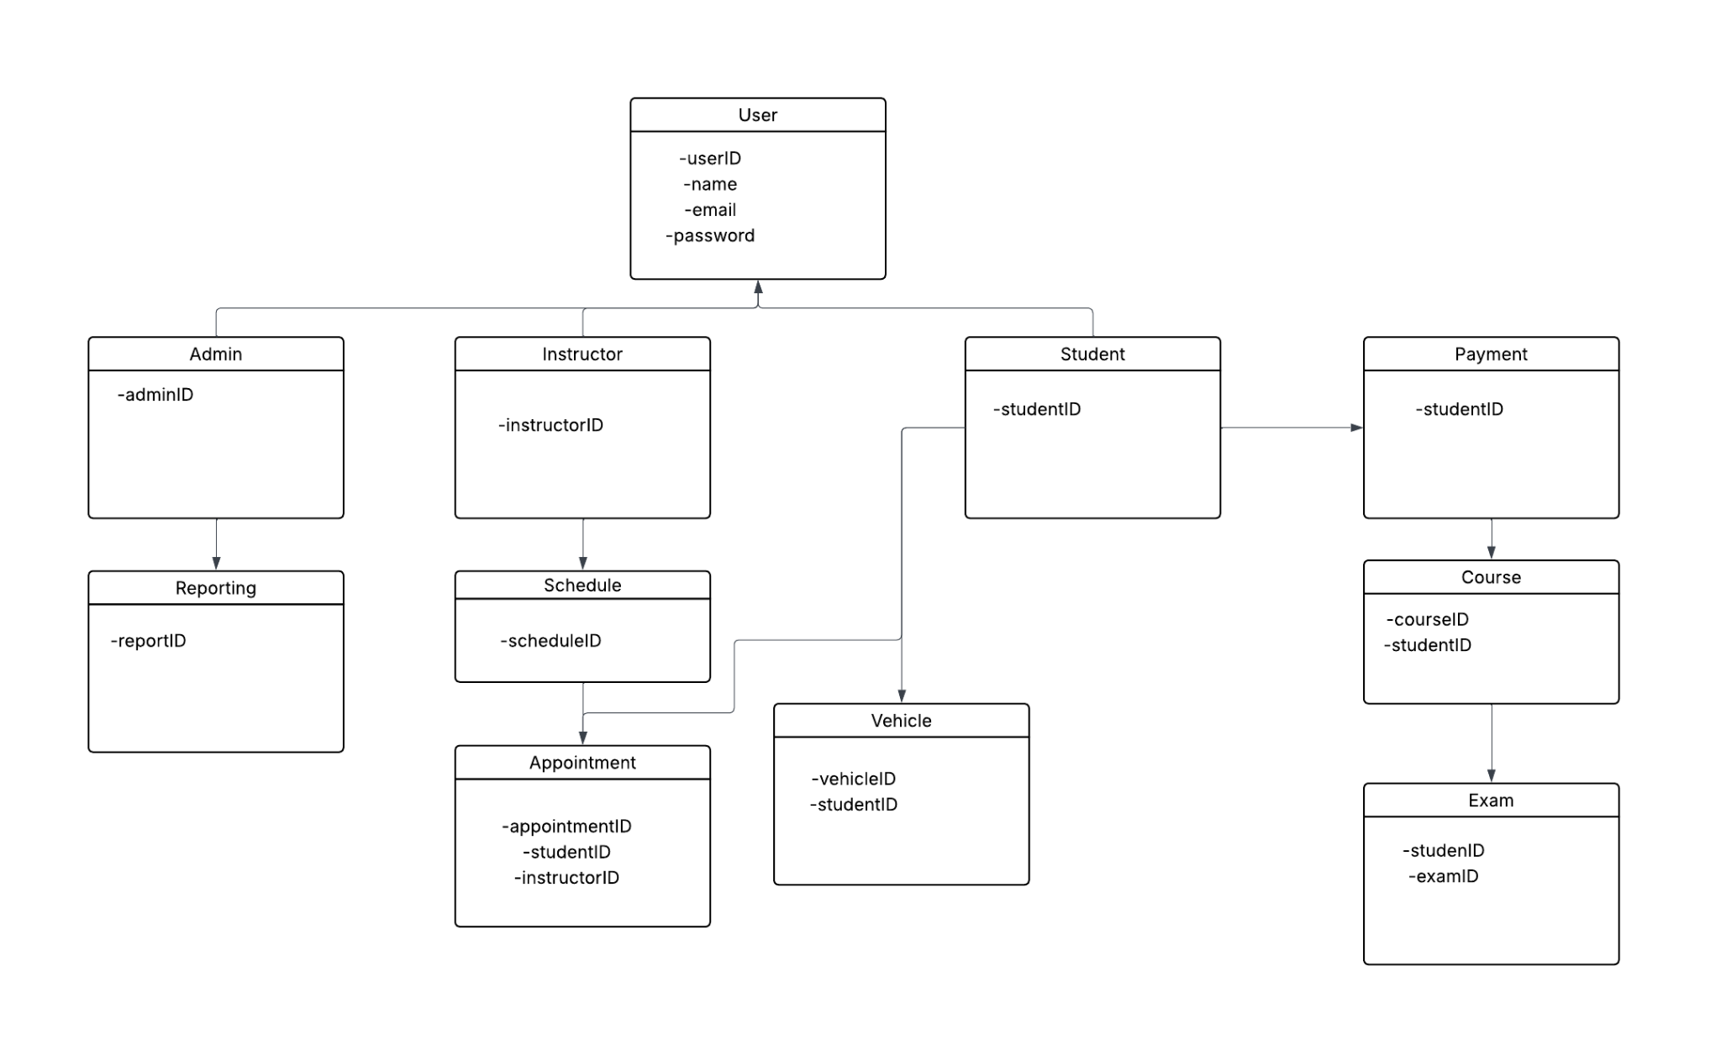

## Technical Requirements

Hardware Requirements

* Dedicated Server (if not using cloud storage)
* Internet Connection
* External storage for reports and data
* Computer for Admin access and on-site needs
* Some sort of security measures

Software Requirements

* SQL server for database
* Cloud storage as a backup
* Security for payment processing
* Security for customer login information
* Server to host the website

Tools/Infrastructure

* Website should be accessible on both mobile and desktop devices
* Physical office location for the business
* Could secure a remote location for driving practice